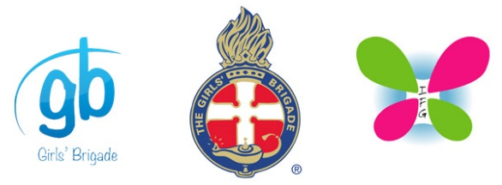
GBNZ COVID-19 Framework

Cleaning Requirements for GBNZ Companies/ Units

The following outlines the cleaning that will be performed before and after a Group/ Unit meeting.
Item | Cleaned with | Completed
Tables – Tops and sides
Chairs – Backs of chairs
Benches – Wipe down top, sides
Light switches and Doors – Wipe down all light switches and door handles
Toilets – clean toilets, basins, wipe down soap dispenser, paper towel dispenser, rubbish bin empty and lid wiped down, mop floor
Wipe down any shared resources such as scissors, glue sticks, game equipment etc.

Add any other items specific to your Company/ Unit.

